### A

**Project Report on**

## “AgriCare -The Farming App”

**SUBMITTED FOR PARTIAL FULFILLMENT FOR THE AWARD OF**

**DIPLOMA IN COMPUTER ENGINEERING**

**SUBMITTED BY**

|  |  |
| --- | --- |
| **Student Name** | **Seat No.** |
| **Ms. Vaishnavi B. Hosmani** | **193678** |
| **Ms. Snehal K. Kalburgi** | **245864** |
| **Ms. Aarti S. Dhupad** | **193694** |
| **Ms.Shilavanti S.Malge** | **193695** |

**UNDER THE GUIDANCE OF**

**Ms.Joshi V.V**



**DEPARTMENT OF COMPUTER ENGINEERING SHRI SIDDHESHWAR WOMENS’S POLYTECHNIC, SOLAPUR - 413 002**

**2022-23**

**Shri Siddheshwar Devasthan Trust’s**

## Shri Siddheshwar Women’s Polytechnic, Solapur

## (Re-Accredited by NBA, New Delhi)





This is to certify that the Project Report entitled

**“QR Code Based Vehicle Registration”**

submitted by

**Student Name Seat No.**

|  |  |  |
| --- | --- | --- |
| **Ms** | **Vaishnavi B. Hosmani** | **193678** |
| **Ms.** | **Snehal K. Kalburgi** | **193684** |
| **Ms.** | **Aarti S. Dhupad** | **193694** |
| **Ms.** | **Shilavanti S. Malge** | **193695** |

Students of final year of Diploma in Computer Engineering have completed the project assigned as per syllabus satisfactorily under the supervision of Ms.Joshi V.V for the academic year 2022 - 2023.

**Mr. Mane N. K. Ms.Joshi V.V**

**(Head of Department) (Guide )**

**Dept. of Computer Eng. Dept. of Computer Eng.**

**Prof. Dharane G.R.**

**(Principal)**

**Shri Siddheshwar Women’s Polytechnic, Solapur.**

**External Examiner Name & Sign: Place: Solapur**

**Date: / /**

### 

### Acknowledgement

It was very exciting for us to work on the project entitled “QR Code Based Vehicle Registration”. During this work we have gained both practical as well as theoretical knowledge of great significance.

We are greatly thankful to all faculty members of college to guide us through this work. We are greatly obliged to our respected guide Ms. Joshi V.V for her suggestions and help. It has been a highly encouraging and knowledge gaining experience. She has been a source of inspiration throughout the project and has helped us in all our problems.

Finally, we would like to thank Mr. Mane N.K. Head of Department of Computer Engineering Department, whose sincere and careful guidance led us to complete this project.

We express our deep sense of gratitude to Prof. Dharane G. R. our Principal for his constant interest and encouragement throughout the completion of my dissertation.

We also thankful to our parents and friends for their extended support and valuable guidance.

**Ms. Vaishnavi Hosmani**

**Ms. Snehal Kalburgi**

**Ms. Aarti Dhupad**

**Ms. Shilavanti Malge**

### Abstract

To remove above problems, we are developing a platform which helps Traffic Police, Government and Also for Vehicle Owner. As soon as owner registers a bike with RTO, RTO will generate a unique QR Code for every Owner. RTO should make compulsory to stick it on Vehicles. As Soon as traffic police scan this QR Code they will get all the details like which vehicle it is, manufacturer, colour, by checking the details they can find it weather the details matches with vehicle or not. If not matching then it can be stolen vehicle.

When someone registers the vehicles in RTO the date of registration is added in database. Initially the **RC is valid for 15 Years**. After 15 Years RC Renewal Update will be sent via SMS. If the **owner Fails to Renew RC** then automatic **fine** is get added on that Vehicle. This can be recovered in so many ways. By this method the revenue of government gets increased.

At the time of vehicle registration, we are adding alternate numbers of family members. We are adding emergency scan in Traffic police App. When accident occurs the traffic police just need to scan the qr code if it is damaged they can enter the number manually and fetch the details, if the details matches with the vehicle then traffic police just need to click on OK, which automatically sends the SMS to Family members about the accident of Vehicle.

# Contents

1. Introduction 7
2. Literature Review 8
3. Requirement Analysis 9
   1. Requirement Specification 9
      1. Functional Requirement 9
      2. Non-Functional Requirement 9
   2. Hardware Requirements 10
   3. Software Requirements 10
4. Project Management 11
   1. Project plan 11
5. Problem Statement 12
   1. Problem Definition 12
   2. Objective 12
   3. Scope 12
6. System Design 13
   1. Data Flow Diagram 14
7. Implementation Details 15
   1. Figure 7.1:User Login 15
   2. Figure 7.2:User Register 15
   3. Figure 7.3:View bill 16
   4. Figure 7.4 :View Users 16
   5. Figure 7.5: Split Bill 17
   6. Figure 7.6: Dashboard 18
   7. Figure 7.7: Add Bill
8. System Testing 19
   1. Test Cases 19
9. Conclusion and Future Scope 30
10. References 31

**List of Figures**

* 1. Level 1 13
  2. Level 2 14
  3. Figure 7.1:User Login 15
  4. Figure 7.2:User Register 15
  5. Figure 7.3:View bill 16
  6. Figure 7.4 :View Users 16
  7. Figure 7.5: Split Bill 17
  8. Figure 7.6: Dashboard 18
  9. Figure 7.7: Add Bill

# Chapter1

**Introduction**

When someone purchases any kind of vehicles, company showroom make registration of that vehicle in the RTO. RTO ads some basic information of vehicle and owner. This information can be fetched based on number. The Traffic Police has the Mobile app which needs to enter the vehicle number. After entering number they get the details, such as owner information, Vehicle information. If any vehicle owner mate with the accident then it is little bit difficult to contact his/her relatives. Traffic police don’t get information weather the vehicle has valid RC or not. In India Millions of RC Expired vehicles are running on road. Due to which revenue of Government of India is unrecovered. Traffic Police can’t find weather the vehicle in front of them is of owners or stolen.

# Chapter2

**Literature of Review**

QR code technology has been widely used in various fields due to its high data storage capacity, easy scanning, and quick decoding. In the field of vehicle registration, QR codes have been used to prevent Stolen Vehicle, expired registration certificate (RC), and accidents. This literature review aims to explore the current state of QR code-based vehicle registration and its effectiveness in preventing car theft, expired registration certificate (RC), and accidents.

**QR Code-Based Vehicle Registration to Prevent Stolen Vehicle:**

QR code based vehicle registration is an innovative method to prevent stolen vehicles. This technology works by sticking a QR code on the vehicle, which contains the vehicle registration details. The QR code is Scanned by the traffic police person to verify the vehicle registration. In case of stolen vehicle, the police can quickly identify it by the scanning the QR code and comparing the details with the central database.

**QR Code-Based Vehicle Registration to Prevent Expired RC:**

QR code-based vehicle registration is also effective preventing expired registration certificates. In India, it is mandatory to renew the RC of a vehicle every five years. However, many vehicle owners do not renew their RC, which leads to legal issues and fines. QR code-based vehicle registration helps in preventing expired RC by providing a quick and easy way to check the status of the RC.

**QR Code-Based Vehicle Registration to Prevent Accidents:**

QR code-based vehicle registration is also effective preventing accidents. This technology works by sticking a QR code on the vehicle, which contains the vehicle registration details and the alternate mobile number and send message option . In case of an accident, the QR code can be scanned by the traffic police to access the vehicle registration details. This helps in quick identification of the vehicle owners details and also can traffic police as soon as possible contact to their owner relatives with the help of alternate mobile number.

# Chapter 3 Requirement Analysis

# 3.1 Requirement Specification

# 3.1.1 Functional Requriement

### Vehicle Registration:

### The QR Code based Vehicle Registration is only accessible for the RTO and the QR Vehicle application is only accessible for the traffic police.

### QR Code Generation:

### The system should be able to generate a unique QR code for each vehicle registration.

### Data Collection:

### The system should collect data such as the vehicle owner's name, contact information, vehicle Type, model, license number, and any other required information.

### Data Validation:

### The system should validate the data provided during the registration process, ensuring that all mandatory fields are filled in correctly.

### Storage and Retrieval: The system should store all the data collected during the registration process in a secure database for future retrieval.

### 3.1.2 Non-Functional Requirement

### Security: The system should be secure, ensuring that all user data is protected from unauthorized access and ensuring that the QR code cannot be easily duplicated or altered.

### Performance: The system should be able to handle a large number of requests simultaneously without any delay or downtime.

### Scalability: The system should be scalable to accommodate an increasing number of users and data as the system grows.

## Hardware Requirements: -

* + - * I3 compatible or Higher Processor
      * 4GB of RAM (Minimum).
      * 40 GB HDD (Minimum).
      * Standard Keyboard Mouse
      * Monitor

## Software Requirements: -

* + - * Windows 7 Or Higher OS
      * Android Studio
      * Visual Studio

**Chapter 4**

**Project Management**

**4.1 Project Plan**

With reference to above project topic, we will provide the solution to the Government the QR code-based vehicle registration system is a software solution designed to tackle issues related to stolen vehicles, expired RC, and accident vehicles. The system provides a unique QR code to every registered vehicle owner, which can be scanned by traffic police to get the details of the vehicle, including the owner's name, registration number, engine number, chassis number, and insurance details.

The system will consist of two main components: a QR code scanner and a database. The QR code scanner will be installed in traffic police mobile. The scanner will be used to scan the QR. The information contained in the QR code will be sent to the database for processing.

Firstly, we have gathered all the required information about the pages.

* We have installed Visual Studio Code 2010 and Android Studio for creating our project. In that we created different User Interface that is our pages Login, Add Vehicle, Insurance details, PUC details and many more.
* We had create different tables in databases like vehicle table, PUC table, Insurance table and many more.
* For creating database, we use Microsoft SQL Server Manager Studio.

Table 4.1: Plan for project

|  |  |  |  |
| --- | --- | --- | --- |
| **Sr. No** | **Name of Activity** | **Conducted By** | **Proposed Schedule** |
| 1. | Requirement gathering | Ms. Vaishnavi S.H and  Ms. Snehal K.K | 9 Oct to 16 Oct |
| 2. | Analysis of system | Ms. Aarti S.S and  Ms. Shilavanti S.M | 23 Oct to 30 Oct |
| 3. | Technical specification | Ms. Vaishnavi S.H and  Ms. Aarti S.S and | 1 Dec to 12 Dec |
| 4. | Coding | Ms. Snehal K.K and  Ms. Shilavanti S.M | 13 Dec to 31 Dec |
| 5. | Implementation | Ms. Shilavanti S.M and  Ms. Vaishnavi S.H | 1 Jan to 18 Jan |
| 6. | Testing | Ms. Snehal K.K and  Ms. Aarti S.S | 21 Jan to 10 Feb |

**Chapter 5**

**Problem Statement**

## Problem Definition

The current vehicle registration system does not have an efficient way of identifying stolen vehicle, or accident vehicles, which poses a significant problem for law enforcement agencies and the public.

Stolen vehicles are difficult to trace, and the recovery rate is low due to the lack of a proper identification system.

Expired RC vehicles can cause safety concerns as they may not be roadworthy, and accidents involving them can result in significant damage and loss of life.

Moreover, accidents involving unidentified vehicles can make it challenging to identify the vehicle owner and obtain insurance details.

## Objective

The primary objective of this project is to create a secure and efficient system that will allow traffic police to quickly identify stolen, expired RC, or accident vehicles, and take appropriate action.

## Scope

**Stolen Vehicles:**

The system will be able to identify stolen vehicles by scanning the QR code on the vehicle.

The QR code will be linked to the vehicle owner's details and the system will notify the police if the vehicle has been reported as stolen.

**Expired RC:**

The system will check the RC status of the vehicle by scanning the QR code. If the RC has expired, the system will notify the police, and appropriate action will be taken.

**Accident Vehicles:**

If a vehicle has been involved in an accident, the traffic police scan the QR code and get the details and contact to their owner relatives as soon as possible.

# Chapter6

# System Design

## 6.1 Data Flow Diagram

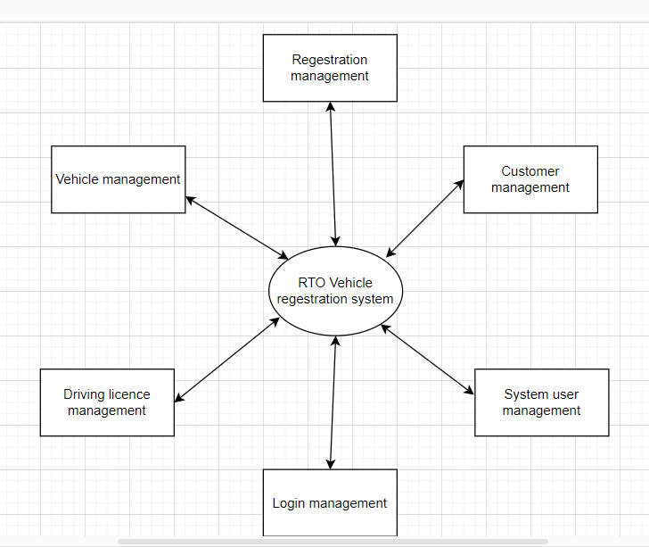

**DFD LEVEL 0**

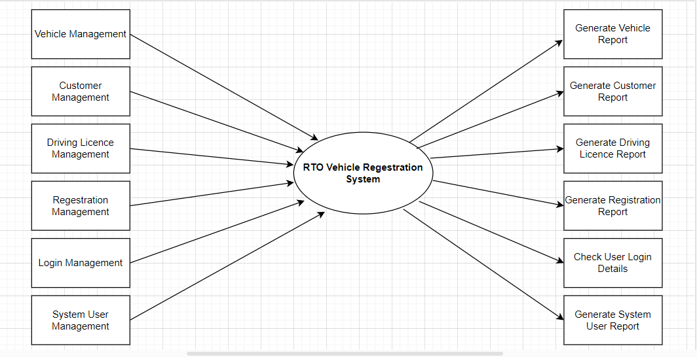

**DFD LEVEL 1**

# Chapter7

# Implementation Details

**Snapshot of our System:**

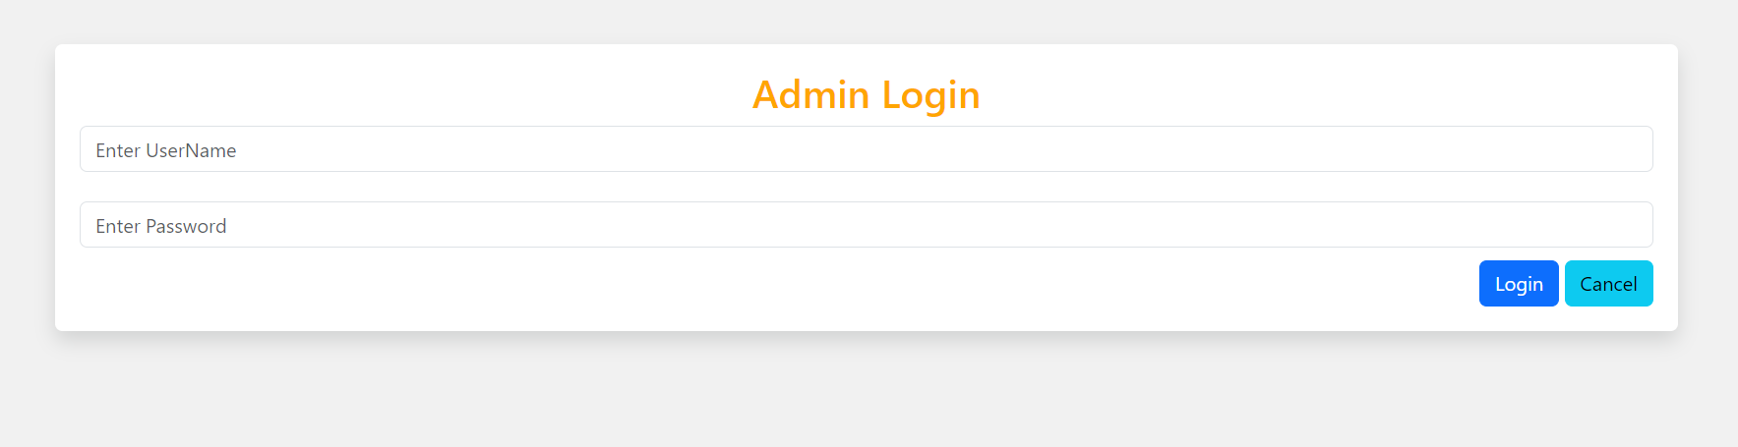

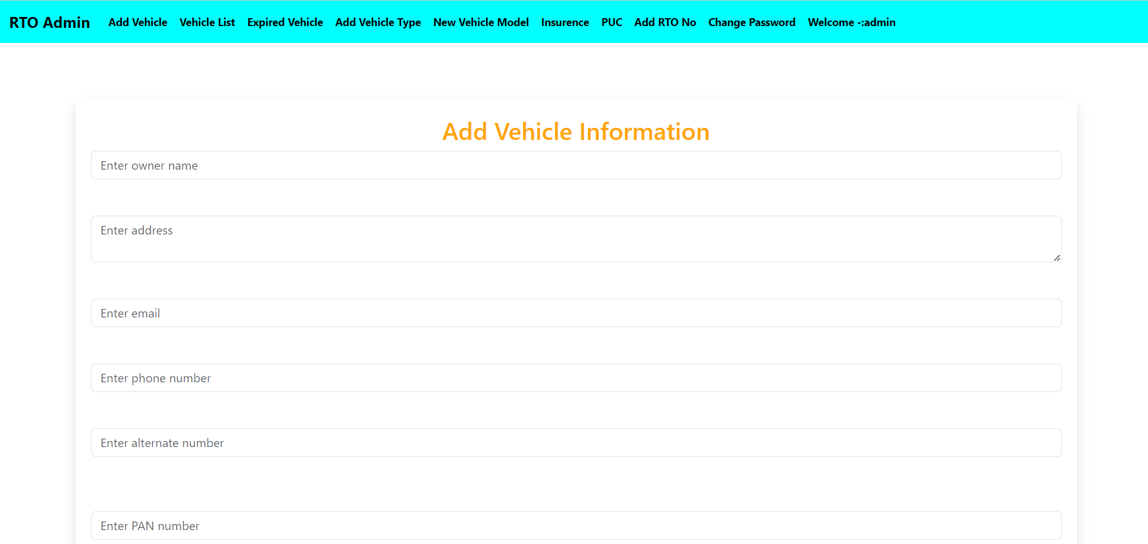

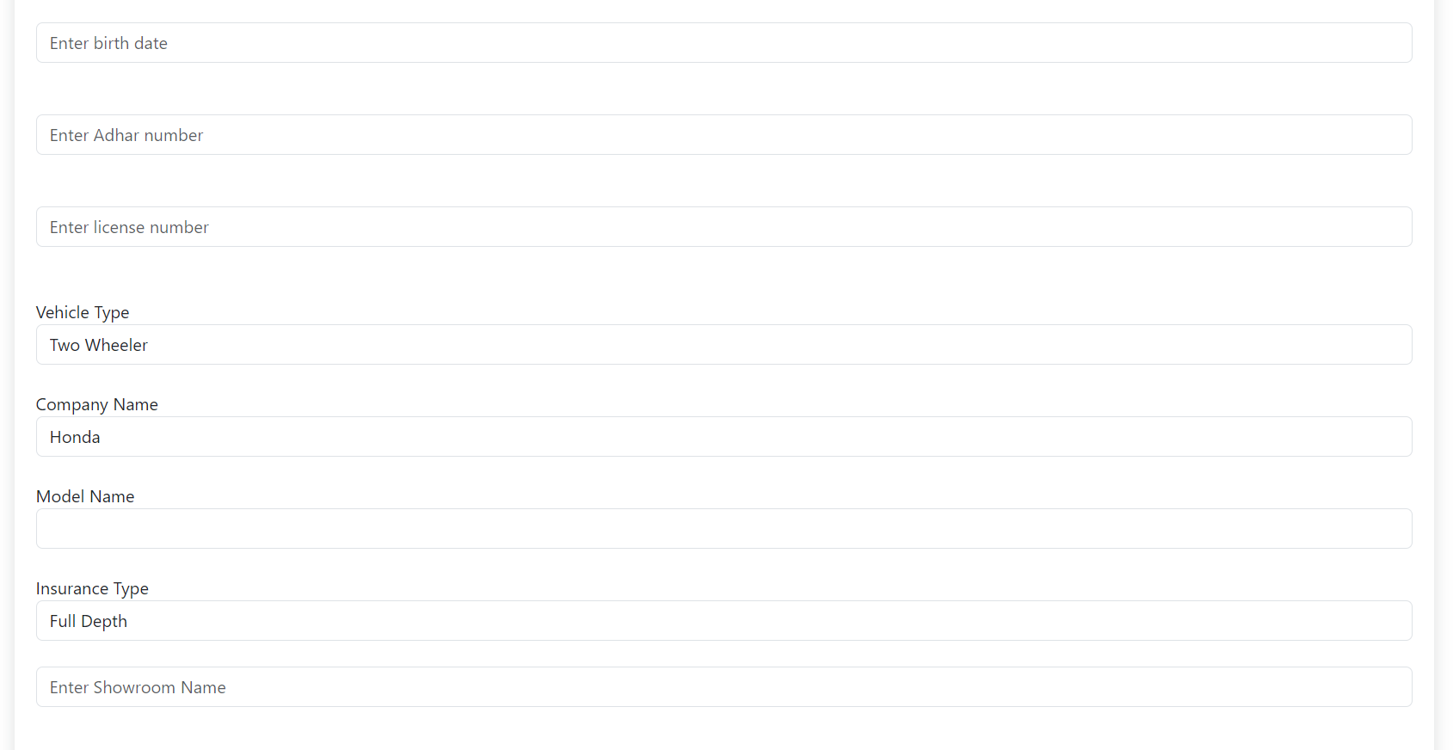

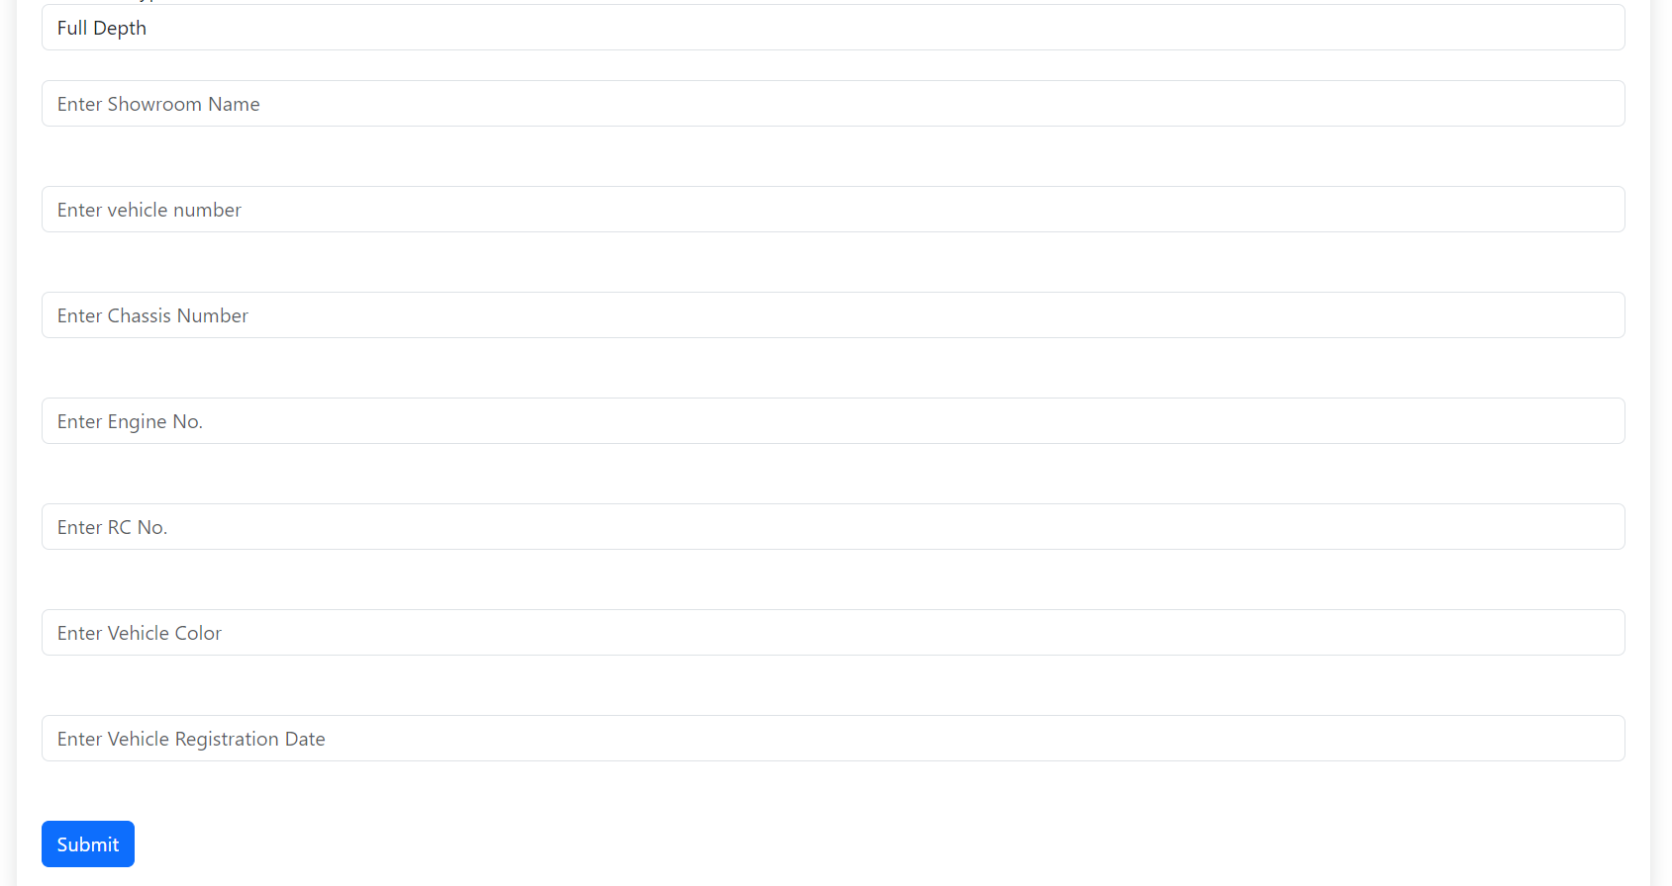

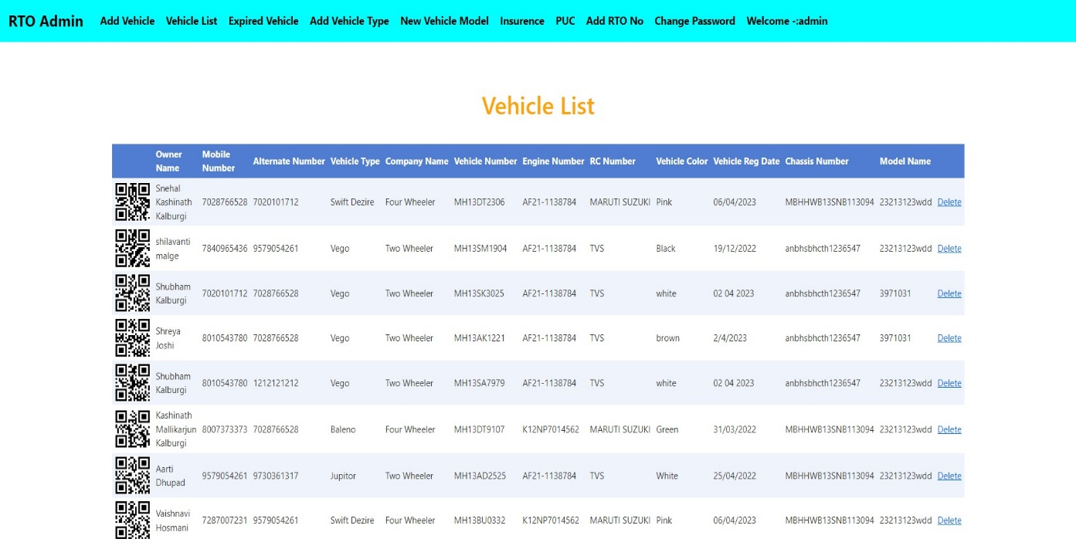

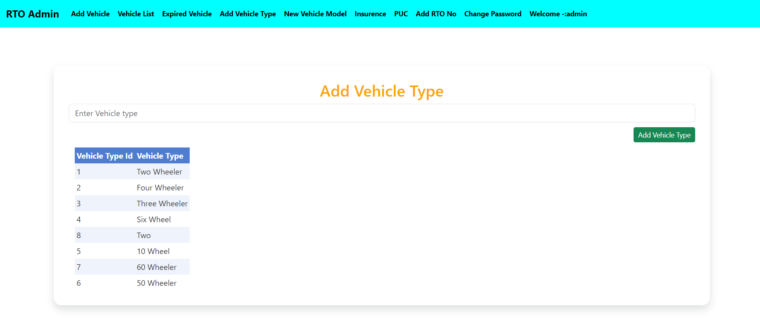

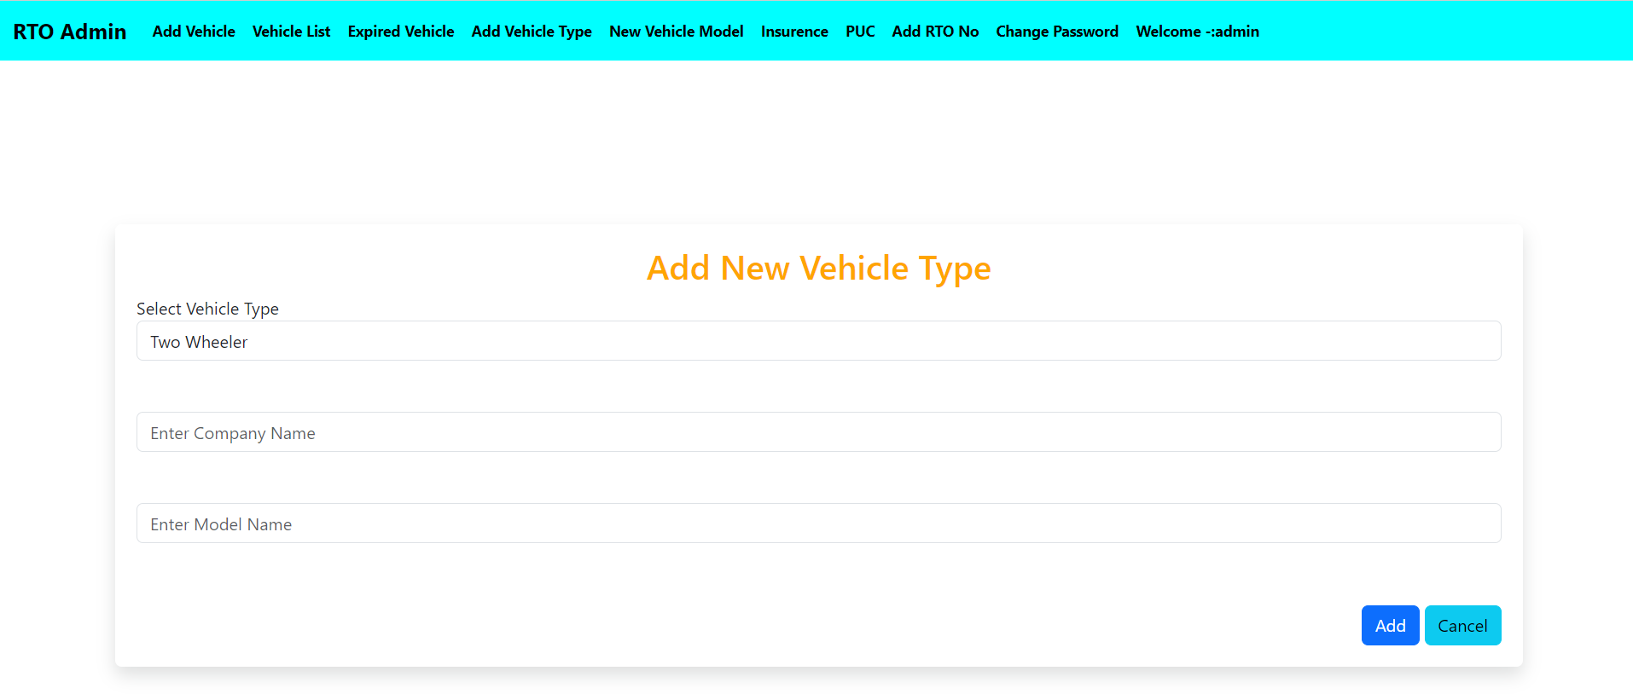

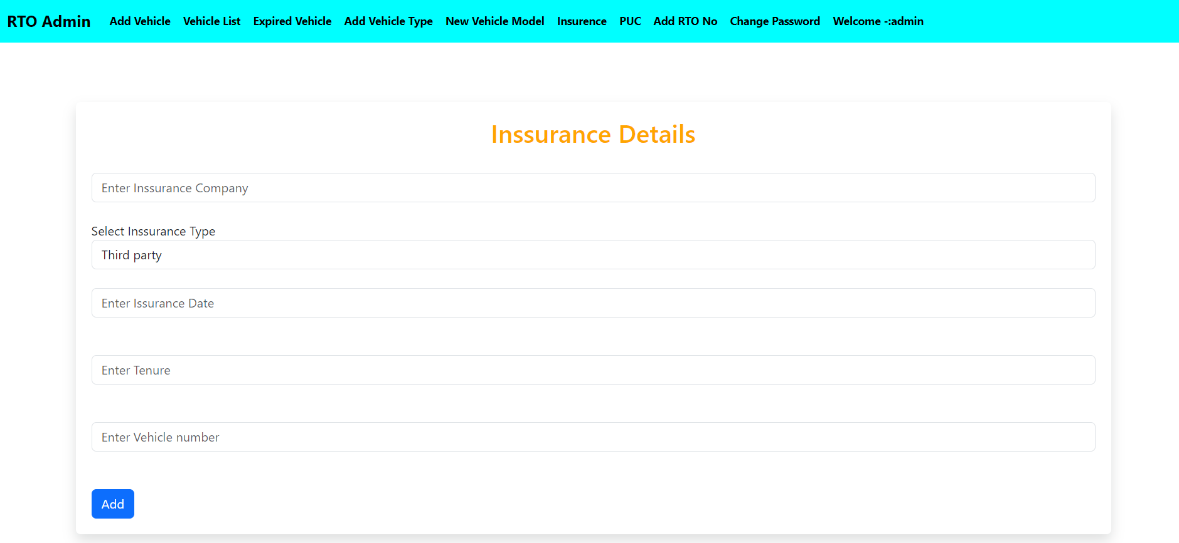

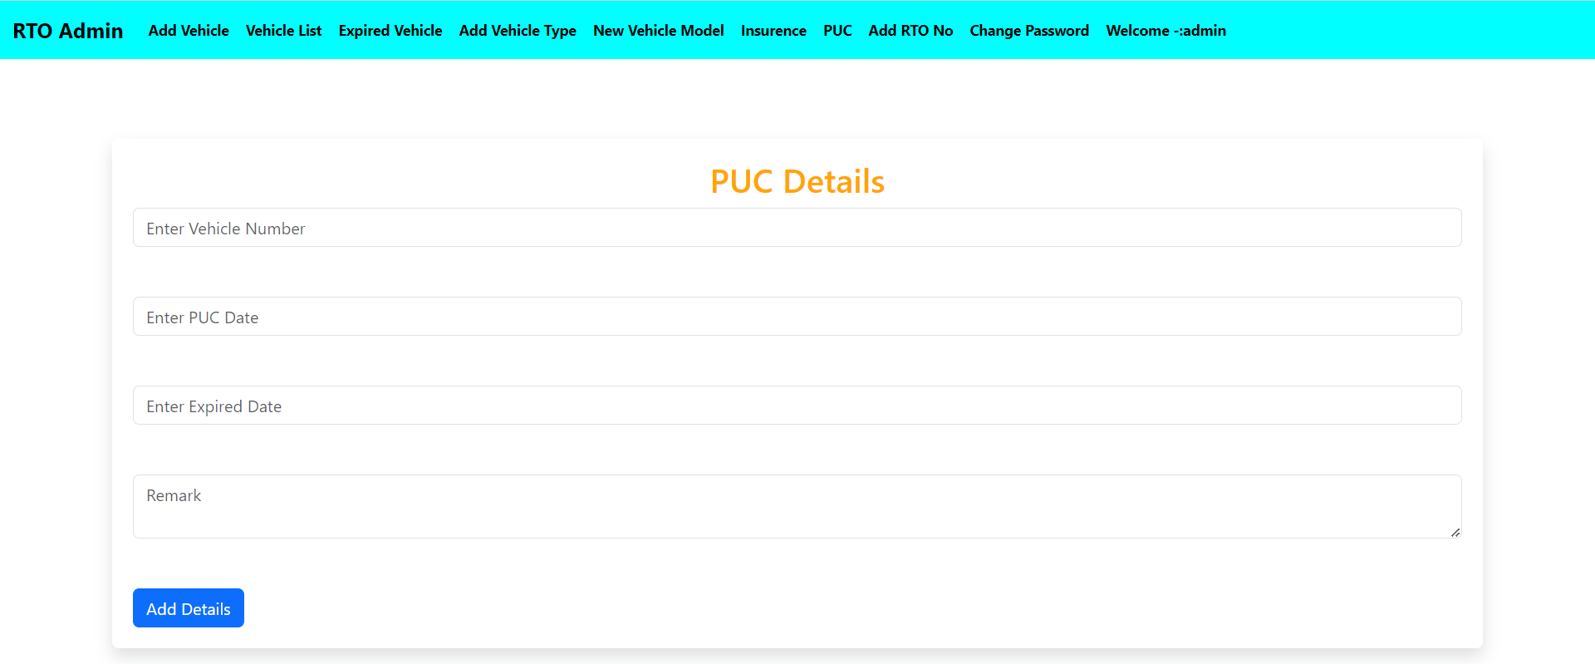

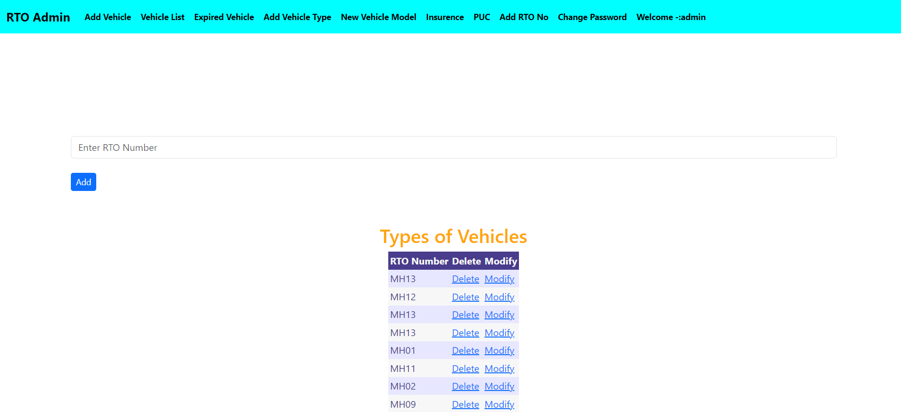

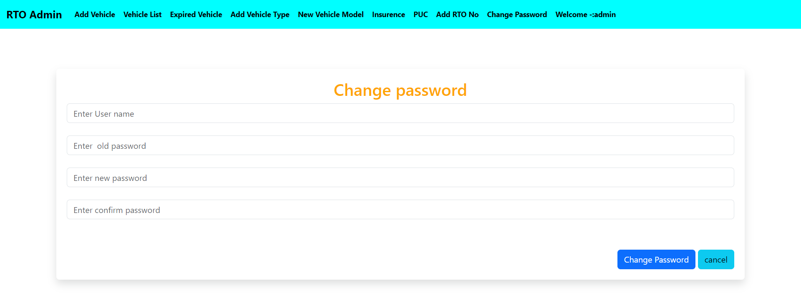

# Chapter8

# System Testing

## 8.1 Test Cases

Login Page

|  |  |  |  |  |
| --- | --- | --- | --- | --- |
| **Test Case** | **Feature** | **Description** | **Steps** | **Expected Results** |
| TC-01 | User Interface | Check all the text boxes and buttons | Check Pages | UI should be perfect • Text boxes and button should be aligned |
| TC-02 | Required Fields | Check the required fields by not filling any data. | 1. Enter invalid username | User should not log in and should show proper error message |
| 2. Enter correct password |
| 3. Click on Login Button |
| TC-03 | User Login | Check When passing a correct username and invalid password | 1. Enter valid username | User should not log in and should show proper error message |
| 2. Enter incorrect password |
| 3. Click on Login Button |
| TC-04 | User Interface | Check Keeping Password | 1. Enter valid username | User should not log in and should show proper error message |
| 2. Do not enter password |
| 3. Click on Login Button |
| TC-05 | User Login | Check when pass correct email and password | 1. Enter valid username | User should log in |
| 2. Enter valid password |
| 3. Click on Login Button |
| TC-06 | User Login | Check if the password is entered in encrypted | 1. Enter valid username | Password is entered in encrypted form |
| 2. Enter password |
| 3. Click on Login Button |
| TC-07 | Signup Option for new users | Check whether the signup link for the new user is working | Click Signup link | Clicking signup link takes the user to signup page successfully |
| TC-08 | Forgot Password | Verify user should get an error message when he/she enters not registered email id. | 1. Click on the Forgot password link. | User should get an error message. |
| 2. Enter unregistered email id and click on the send button. |
| TC-09 | Reset Password | Verify user should get an error message when he/she enters the previous password. | 1. Go to the reset password link. | User should get an error message. |
| 2. Enter the previous password. |
| 3. Click on the Reset Password button. |
| TC-10 | Reset Password | Verify user able to reset his/her password | 1. Go to the reset password link. | Users should get the success message and the password should get reset. |
| 2. Enter a new password and a confirm password. |
| 3. Click on the Reset Password button. |
| TC-11 | Reset Password | Verify user should get an error message when password and confirm password not matches | 1. Go to the reset password link. | Users should get an error message. |
| 2. Enter a different new password and a confirm password. |
| 3. Click on the Reset Password button. |
| TC-12 | Reset Password | Verify user should able to login with a new password. | 1. Go to the reset password link. | User should able to login |
| 2. Enter a new password and a confirm password. |
| 3. Click on the Reset Password button. |
| 4. Log in by using the new password. |
| TC-13 | Reset Password | Verify if the user enters a new password that does not cover the basic requirements of password then the user should be displayed error message | 1. Go to the reset password link. | Users should get an error message. |
| 2. Enter a new password that does not cover the basic requirements. |
| 3. Click on the Reset Password. |
| TC-14 | Required Fields | Verify if blank spaces are passed in required fields. | 1. Go to the Site. | Those Blank spaces should trim and Validation error message for required fields should visible. |
| 2. Passed blank spaces in required fields. |
| 3. Click on the Login button |
| TC-15 | Welcome Email | Verify new users should get the welcome email once after the login. | 1. Go to the Email. | Users should get a welcome email on his/her email id. |
| 2. Enter Login Email. |
| TC-16 | User Login | Verify when passing incorrect Email and correct password | 1. Enter incorrect Email. | User should not be able to log in and the error message should be displayed. |
| 2. Enter the correct password. |
| 3. Click on the Login Button. |
| TC-17 | User Login | Verify when passing both incorrect Email and password | 1. Enter incorrect Email. | User should not be able to log in and the error message should be displayed. |
| 2. Enter the correct password. |
| 3. Click on the Login Button |

Register Page

|  |  |  |  |  |  |
| --- | --- | --- | --- | --- | --- |
| **Test Cases** | **Features** | **Description** | **Steps** | **Input** | **Expected Result** |
| TC_1 | User Interface | Check all the text boxes, radio buttons, buttons, etc | 1. Click on Radio buttons, buttons and dropdowns | N/a | UI should be perfect |
| TC_2 | Required fields | Check the required fields by not filling any data | 1. Do not enter any value in the field. | N/a | It should show a mandatory symbol (*) on mandatory fields. |
| 2. Click on the Register button. |
| TC_3 | Required fields | Check user should Register by filling all the required fields | 1. Enter valid values in the required fields. | N/a | 1. Users should be registered successfully. |
| 2. Click the Register button. | 2. A successful registration message should show. |
|  | 3. Mail should send to the user |
| TC_4 | Optional Fields | Check all the optional fields when do not fill data | 1. Do not enter any detail in optional fields | N/a | 1. It should not ask to fill the optional fields |
| 2. Enter valid data in required fields | 2. User should be registered successfully |
| 3. Click on the Signup button | 3. A successful registration message should show |
|  | 4. Mail should send to the user |
| TC-5 | Optional Fields | Check all the optional fields when filling data | 1. Enter valid data in optional fields | N/a | 1. User should be registered successfully |
| 2. Enter valid data in required fields | 2. A successful registration message should show |
| 3. Click on the Register button | 3. Mail should send to the user |
| TC-6 | Email validation | • Check the Email text field that has an Email address without @ symbol. • Check the Email text field that has a random string instead of a real email. • Check the Email text field that has @ symbol written in words. • Check the Email text field that has a missing dot in the email address. | 1. Enter Invalid Emails | 1.testAtgmail.com | It should show the validation message for valid email |
| 2. Click on the Register Button. | 2.test@gmailcom |
|  | 3.test@gmail |
|  | 4.@gmail |
| TC_7 | Email validation | Check all the valid emails | 1. Enter valid Emails | 1.test.22@gmail.com | It should not show any validation message |
| 2. Click on the Register Button. | 2.test@gmail.com |
| TC_8 | Phone Number validation | Check the phone number when passing alphanumeric data | 1. Enter alphanumeric data in phone field | 1. dada5$7567#7 | It should show the validation message 8 for Phone Number |
| 2. Click on Register button |
| TC_9 | Phone Number validation | Check the phone number when not pass country code | 1. Enter valid phone number without country code | 1. 9012078654 | It should show the validation message for country code is required |
| 2.Click on Register button |
| TC_10 | Phone Number validation | Check the phone number when passing country code | 1. Enter valid phone number with country code | 1. +9190112244 | It should not show any validation message |
| 2.Click on Register button |
| TC_11 | Password Validation | Check the password limit when enter value less than min | 1. Enter value which is alphanumeric but less than 8. | 1. Password | It should show validation message |
| 2.Click on Register button |
| TC_12 | Password Validation | Check the password limit when enter value greater than max | 1. Enter alphanumeric value but more than 32. | Any Random string with numbers | It should show validation message |
| 2.Click on Register button |
| TC_13 | Password Validation | Check the password when passing only numbers | 1. Enter a value in numbers which is in between 8-32 | 1. 12345678 | It should show validation message |
| 2.Click on Register button |
| TC_14 | Password Validation | Check the password when passing valid data | 1. Enter value in alphanumeric which is in between 8-32 | 1. Pass123456 | It should not show any validation message |
| 2.Click on Register button |
| TC_15 | Required Fields | Verify if blank spaces are passed in required fields. | 1. Go to the Site. | N/a | Those Blank spaces should trim and Validation error message for required fields should visible. |
| 2. Passed blank spaces in required fields. |
| 3. Click on the Register button |
| TC_16 | Required Fields | Verify user can verify its Email ID | 1. Go to the Email. | test22@gmail.com | User should get a verification link and able to verify his/her Email ID. |
| 2. Click on the verification link. |
| TC_17 | Phone Number Validation | Verify if the length of the phone number is incorrect i.e. less than 10. | 1. Enter phone number less than 10 digits. | 91901122 | It should show the validation error message for phone number length. |
| 2.Enter all required fields. |
| 3.Click on Register Button |
| TC_18 | Phone Number Validation | Verify if the length of the phone number is incorrect i.e. more than 10 | 1. Enter phone number less than 10 digits. | 9.1901E+13 | It should show the validation error message for phone number length. |
| 2.Enter all required fields. |
| 3.Click on Register Button |
| TC_19 | Password Validation | Verify if the password required rules are not satisfied in the password | 1. Enter the password which not satisfies the required rule. | passw | It should display error with required rules for password value (like it should contain a special character, a small case, a number) |
| 2.Click on Register button |

Add Bill

|  |  |  |  |  |  |
| --- | --- | --- | --- | --- | --- |
| **test case id** | **test case feature/condition** | **description** | **steps** | **expected output** | **pass/fail** |
| TC-1 | bill no | it must contains only numbers | user must enter all the bill no | bill number must have to be entered | pass |
| TC-2 | bill no | it doesnot contain any alphabate | user must enter all the numbers | bill number must have to be entered | fail |
| TC-3 | bill Date | it must contains only numbers | user must enter bill date only in date format | bill Dtae must have to be entered | pass |
| TC-4 | bill Date | it doesnot contain any alphabate | user must enter only in the date format | bill Date must have to be entered | fail |
| TC-5 | Bill Amount | it must contains only numbers | user must enter all the bill amount | bill amount must have to be entered | pass |
| TC-6 | Bill Amount | it doesnot contain any alphabate | user must enter all the numbers | bill amount must have to be entered | fail |
| TC-7 | Category | It must contain String Value | user must enter the category only in the string | Category must have to be entered | Pass |
| TC-8 | Category | It does not cantain Blank Text Box,it Throws the required Errror | user must enter the category only in the string | Category must have to be entered | Fail |
| TC-9 | Product | It must contain String Value | user must enter the product only in the string | Product must have to be entered | Pass |
| TC-10 | Product | It does not cantain Blank Text Box,it Throws the required Errror | user must enter the product only in the string | Product must have to be entered | Fail |
| TC-11 | Back Button | After clicking on Back Button Event Occurs | Click on the Back Button | Dashboard Page must be opened | Pass |
| TC-12 | Clear Button | After clicking on Back Button Event Occurs | Click on the Clear Button | All Text Box must be Cleared | Pass |
| TC-13 | Add Bill Button | After clicking on Back Button Event Occurs | Click on the Add Bill Button | Filled Data wiil be Stored in the database | Pass |

# View Bill

|  |  |  |  |  |  |
| --- | --- | --- | --- | --- | --- |
| **Test Case** | **Feature** | **Description** | **Steps** | **Expected Results** | **Status** |
| TC_1 | View Bill | Chacke the all the details of the  user details bill | Check page | User should get view bill page | Pass |
| TC_2 | Back button | When user click on back button then go to first page | Click on back button | User should get home screen page | Pass |
| TC_3 | View Bill table | Create table of user view bill | View the bill of  user bill | User should get user bill table | Pass |
| TC_4 | Database Conection | Conection with view bill in database | View bill show on  database | Database should get connecting  with view bill | Pass |
| TC_5 | Database Conection | Conection with view bill in database | View bill show on  database | Database should not get connecting  with view bill | fail |

# Split Bill

|  |  |  |  |  |  |
| --- | --- | --- | --- | --- | --- |
| **test case id** | **test case feature/condition** | **description** | **steps** | **expected output** | **pass/fail** |
| TC-1 | bill no | it must contains only numbers | user must enter all the bill no | bill number must have to be entered | pass |
| TC-2 | bill no | it doesnot contain any alphabate | user must enter all the numbers | bill number must have to be entered | fail |
| TC-3 | Bill Amount | It must contains only numbers | user must enter all the numbers | bill amount must have to be entered | pass |
| TC-4 | bill Amount | it must contains value in INR format | user must enter INR format value | bill amount must have to be entered | pass |
| TC-5 | Splitwise | it must contains value in numbers | user must enter the number | number must have to be enter | pass |
| TC-6 | splitwise | it must have to enter no.of member | user must have enter the no.of people correctly | user must enter the no.of people | pass |
| TC-7 | back button runnable | it must have to go back after click | user must have click | user must have to click on the button | pass |
| TC-8 | split bill | it must have to calculate | user must have to click on the split bill button | user must havre to click on the button | pass |
| TC-9 | split bill | bill amount and splitwise textbox have to be filled | user must fill the splitwise and bill maount field | user must have to enter the splitwise and bill amount | pass |

# Chapter 9

# Conclusion and Future Scope

This project is very helpful for Government, Traffic Police and also for vehicle Owner. In future the QR codes of vehicle owner is linked to adharcard. By using this application it is not necessary to carry all the documents and licence everytime. QR code is being widely used for implementing messages such that people can easily use their smartphone’s to capture the QR code and gain relevant data from QR code reader.

# Chapter10

# References

* <https://www.tutorialspoint.com/asp.net/asp.net_introduction.htm>
* <https://www.javatpoint.com/asp-net-introduction>
* <https://www.tutorialsteacher.com/mvc/create-first-asp.net-mvc-applicationhttps>
* <http://sharpcorner.com/article/sql-server-database-connection-to-mvc-application/>
* <https://www.tutorialspoint.com/how-to-validate-an-email-address-in-chash#:~:text=There%20are%20several%20ways%20to,(SMTP)%20server%20for%20delivery>